FINANCIAL TRANSACTION AND LOAN ANALYSIS DASHBOARD

Project Report - Dataset 4
Submitted By:
Name: Metha shree .B
Roll no - E25FA024
Class: B.Com Fintech with AI (2nd year)
Tool Used: Microsoft Power BI Desktop

Financial Transactions and Loans Dashboard: Analysis Report

1. Introduction
This report documents a Power BI dashboard, "Financial Transactions and Loans Dashboard", built on a retail-banking dataset of 1,029 customers, 853 accounts, 318 loans and 48,510 distinct transactions.
The dashboard gives a one-page view of the bank's customer base, account mix, loan portfolio and transaction activity, plus a hover tooltip page for transaction types. All figures here were computed from the model's underlying tables using the same logic as the dashboard's DAX measures. I could not render the report itself, so they are what the dashboard should show, not a screenshot of it.

2. Objectives
The dashboard and this report set out to do five things:
- Summarise the size of the business: customers, active accounts, active loans and total transaction value.
- Show how accounts are distributed across account types.
- Show how loans are distributed across statuses (Active, Paid Off, Overdue).
- Break transactions down by type and by month.
- Check the quality of the data and the measures behind the visuals, and recommend fixes.

3. Dataset description
The data model has 11 business tables, about 49,000 transaction rows and five small lookup tables. Power BI also added auto-generated date tables for the date columns.
Table | Rows | Key columns
Customers | 1,029 | CustomerID, name, DateOfBirth, AddressID, CustomerTypeID
Accounts | 853 | AccountID, CustomerID, AccountTypeID, AccountStatusID, Balance, OpeningDate
Loans | 318 | LoanID, AccountID, LoanStatusID, PrincipalAmount, InterestRate, StartDate, EstimatedEndDate
Transactions | 49,000 (48,510 distinct IDs) | TransactionID, origin and destination account, type, Amount, TransactionDate, BranchID
Branches | 50 | BranchID, BranchName, AddressID
Addresses | 1,139 | AddressID, Street, City, Country
Time coverage: transactions run from 1 January 2020 to 28 August 2026, accounts were opened between 2018 and 2026, and loans started between 2021 and 2026.
Relationships: Accounts link to Customers, Account Types and Account statuses. Loans link to Loan statuses, and Transactions link to Branches and Transaction types. Customers and Branches link to Addresses. Three relationships are inactive: Loans to Accounts, Transactions destination to Accounts, and Customers to Addresses. Two measures switch on the first two with USERELATIONSHIP. A one-to-one, both-direction relationship also ties Loan statuses to Account statuses by name.

4. Data preparation
The file does not expose the Power Query steps, so this section describes the preparation visible in the model and the checks I ran on the loaded data.
Preparation visible in the model
- Tables are split into facts (Transactions, Loans, Accounts) and lookups (types, statuses, branches, addresses), forming a star-style model.
- Columns carry proper types: whole-number keys, decimals for balances and principal, a float for transaction amounts, and dates for all date fields.
- Power BI's automatic date tables were created for the date columns. The line chart uses the Date Hierarchy on TransactionDate.
- Twelve DAX measures were added (section 5).
Checks run and problems found
Check | Result
Duplicate transaction rows | 490 fully identical rows (49,000 rows vs 48,510 distinct IDs)
Transactions whose origin account is missing from Accounts | 23,676 (48%)
Loans whose account is missing from Accounts | 176 of 318 (55%)
Accounts whose customer is missing from Customers | 57 (6.7%)
Transactions dated before the origin account opened | 3,247
Accounts with negative balance | 4 (total −$1,255), all marked Active
Customers with birth date in 2020 or later | 10
Customers with no matching address | 58
Misspelled country values (e.g. "United Staes") | 11 customers
Loan with end date before start date | 1 (ID 400080)
None of these were corrected in the file I received. The duplicates and the missing accounts affect the dashboard's numbers most, and are covered in the key findings.

5. DAX measures used
The model has 12 measures. Seven appear on the dashboard and five are defined but unused.
Table | Measure | DAX | Used on dashboard
Customers | Total Customers | DISTINCTCOUNT(Customers[CustomerID]) | Yes (card)
Accounts | Total accounts | DISTINCTCOUNT('Accounts'[AccountStatusID]) | Yes (column chart)
Accounts | Active Accounts | CALCULATE(DISTINCTCOUNT(Accounts[AccountID]), 'Account statuses'[StatusName]="Active") | Yes (card)
Accounts | Total account balance | SUM(Accounts[Balance]) | No
Loans | Total loans | DISTINCTCOUNT(Loans[LoanID]) | Yes (donut)
Loans | Active Loans | CALCULATE(DISTINCTCOUNT(Loans[LoanID]), 'Loan statuses'[StatusName]="Active") | Yes (card)
Loans | Total loan principle | SUM(Loans[PrincipalAmount]) | No
Loans | Avearge interest rate | AVERAGE(Loans[InterestRate]) | No
Loans | Total Loan amount | CALCULATE(SUM(Loans[PrincipalAmount]), USERELATIONSHIP(Accounts[AccountID], Loans[AccountID])) | No
Transactions | Total transactions | DISTINCTCOUNT(Transactions[TransactionID]) | Yes (charts, table, tooltip)
Transactions | Total transaction value | SUM(Transactions[Amount]) | Yes (card, table, tooltip)
Transactions | Destination transaction value | CALCULATE(SUM(Transactions[Amount]), USERELATIONSHIP(Accounts[AccountID], Transactions[AccountDestinationID])) | No
Notes on specific measures
- Total accounts counts distinct status IDs, not accounts. Split by account type it returns 3 for every type. The fix is DISTINCTCOUNT(Accounts[AccountID]).
- Total transactions counts distinct IDs, but Total transaction value sums all rows, so the 490 duplicates are counted in value and not in count.
- Total loan principle and Avearge interest rate contain spelling slips in their names.

6. Dashboard components
The report has two pages: "Finance overveiw" (the main page, 1920×1080) and "Tooltip" (400×300). The main page holds ten visuals, and the charts and table use a light-pink fill.
Visual | Type | Fields | Title on dashboard
Banner | Text box | none | Financial Transactions and Loans Dashboard
Customers | Card | Total Customers | TOTAL CUSTOMERS
Active accounts | Card | Active Accounts | ACTIVE ACCOUNTS
Active loans | Card | Active Loans | ACTIVE LOANS
Transaction value | Card | Total transaction value | TOTAL TRANSACTION VALUE
Account mix | Clustered column chart | Account Types[TypeName] by Total accounts | ACCOUNTS BY ACCOUNT YPE
Monthly trend | Line chart | TransactionDate (month) by Total transactions, value axis fixed 3,000–5,000 | TRANSACTIONS BY MONTH
Loan status | Donut chart | Loan statuses[StatusName] by Total loans, labelled with category and percent | TOTAL OANS BY STATUS NAME
Type comparison | Clustered bar chart | Transaction types[TypeName] by Total transactions | TRANSACTIONS BY TYPE
Type summary | Table | TypeName, Total transactions, Total transaction value (data bars on value) | TRANSACTION SUMMARY
I)The dashboard has four KPI cards across the top: Total Customers (1,029), Active Accounts (678), Active Loans (230) and Total Transaction Value ($122.69M). Together they give an instant snapshot of the bank's size and activity, though the transaction value includes 490 duplicate rows and is overstated by about $1.21M.

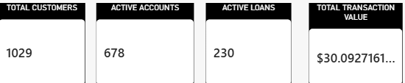
II) The donut chart, titled "Total Loans by Status Name", splits the 318 loans into three statuses: Active 230 (72.3%), Paid Off 54 (17.0%) and Overdue 34 (10.7%). It shows at a glance that most of the loan book is performing, but 198 of the 230 Active loans are past their estimated end date, so the statuses may be out of date.

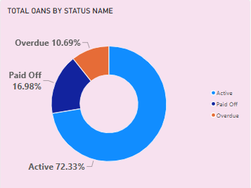
iii) The "Transactions by Month" line chart plots distinct transactions by calendar month, with the value axis fixed between 3,000 and 5,000. January is the peak at 4,908, and the other eleven months sit in a narrow band between 3,773 and 4,079. Because the chart groups by month name without the year, it hides the sharp drop in activity after 2023 (11,533 transactions in 2023, 1,235 in 2024 and 161 in 2025), so adding a year or date slicer would make the trend visible.

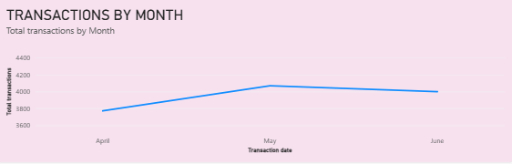

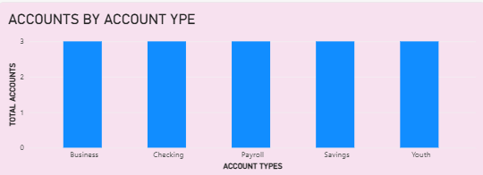
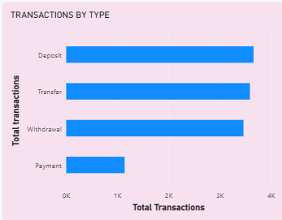

The Tooltip page is a hover page with three cards: the transaction type name, Total transactions and Total transaction value. Power BI shows it when a visual is set to use it as its tooltip, and I could not confirm which visual does.
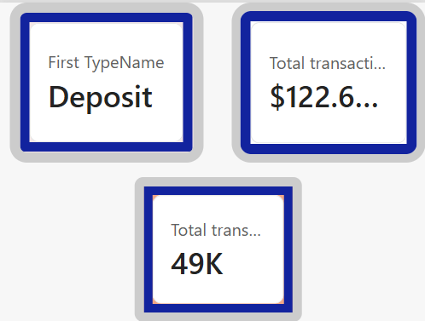

Slicers used
A slicer is an on-page filter in Power BI that lets users pick values, such as a year, a branch or a status, and every visual on the page updates to match. Unlike clicking on a chart, it is always visible, shows what is currently selected, and can be reset with one click.
Slicers come in several styles:
- List: checkboxes for picking one or many values.
- Dropdown: saves space when there are many values, such as 50 branches.
- Buttons or tiles: good for a few options, such as customer types.
- Between (range): a slider for dates or amounts.

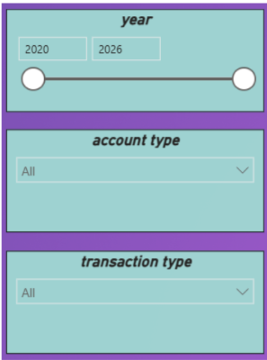

8. Key findings
The bank is mostly healthy on accounts and loans, but transaction activity almost stops after 2023 and several measures and records need correcting.
Headline numbers
Metric | Value
Total customers | 1,029
Accounts | 853 (678 Active, 79.5%)
Total account balance | $41.64M (average $48,812)
Loans | 318 (230 Active, 72.3%)
Total loan principal | $16.40M (average $51,585)
Average interest rate | 8.93%
Distinct transactions | 48,510
Total transaction value as the dashboard calculates it | $122.69M
Customers and accounts
- Customers split almost evenly: Large Enterprise 372 (36.2%), Individual 331 (32.2%) and Small Business 326 (31.7%).
- Accounts by type: Youth 189, Business 177, Savings 171, Payroll 170 and Checking 146. Average balances are nearly identical, between $48.5K and $49.7K.
- Account status: 678 Active, 131 Inactive (15.4%) and 44 Closed (5.2%). Inactive and Closed accounts hold $8.35M, or 20.1% of all balances.
- Four accounts have negative balances, and all four are marked Active.

- Dashboard Visual:-
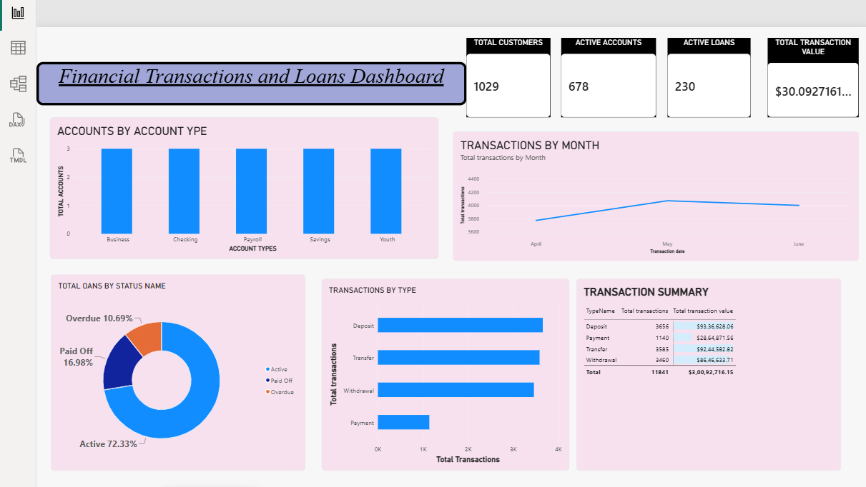

10. Conclusion
The dashboard gives a clear, readable overview of a bank with 1,029 customers, $41.6M in account balances and a $16.4M loan book, of which about 72% is Active and 10% Overdue. Its design is sound, with KPI cards, a mix of chart types and a summary table, but it cannot yet be fully trusted or explored.
The priorities, in order:
- Fix the Total accounts measure so the account-type chart shows real counts.
- Remove the 490 duplicate transactions, or make count and value use the same rows.
- Confirm with the data owner whether the drop in transactions after 2023 is real or a gap in the data.
- Load the missing accounts so transactions, loans and customers can be tied together.
- Review the 198 Active loans past their end date and update statuses.
- Add slicers for date, branch, customer type and statuses, a year-month trend line, and cards for balance, loan principal and average interest rate, which are already built.
- Remove the Loan statuses to Account statuses relationship and correct the typos and axis titles.

11. References
Microsoft, Power BI documentation, for relationships, visuals, slicers and tooltip pages.

